**Summary –Day2**

**Name:Tejaswini Gokanakonda**

## **Roll no**:**DE142**

## **Date:05-11-2024**

**1.RDBMS Overview**

A DBMS (Database Management System) is software that manages and organizes data.

RDBMS (Relational DBMS) structures data in related tables (rows and columns).

Advantages include enhanced data integrity, minimized redundancy, and efficient data handling.

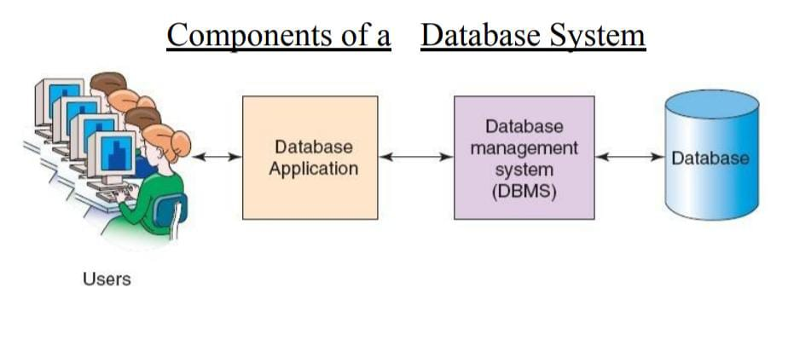

**2. Types of Database Systems**

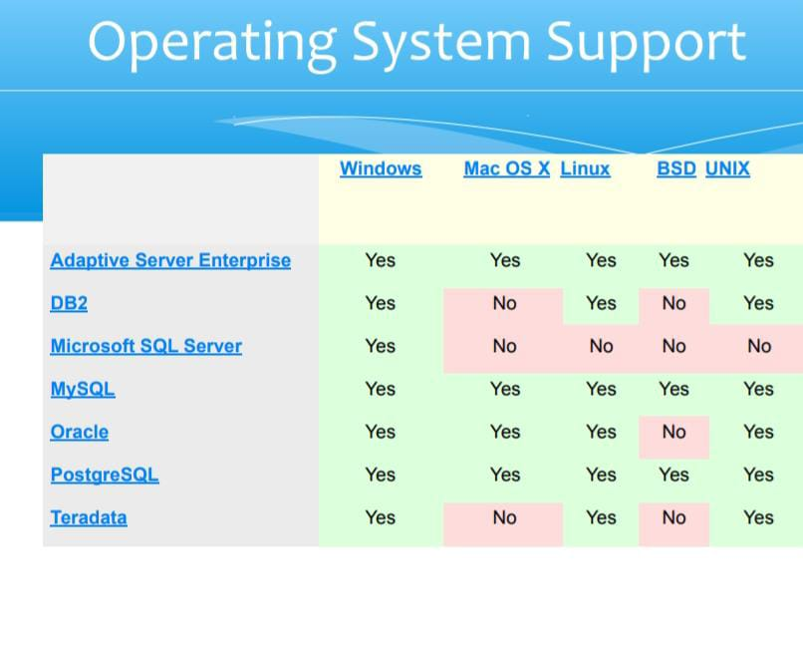

**Commercial RDBMS:**

**Oracle**: Common in large-scale enterprises.

**IBM DB2:** Strong in mainframes and high-end servers.

**Microsoft SQL Server:** Popular for Windows environments.

**Open Source RDBMS:**

**MySQL:** Known for performance, widely used in web applications.

**PostgreSQL**: Known for extensibility and advanced features.

**3. Benefits of MySQL**

**Multi-User Support:** Allows multiple users to access databases concurrently.

**Part of LAMP Stack:** Often used with Linux, Apache, PHP/Perl/Python for web development.

**Widely Trusted:** Used by major companies like Facebook, Wikipedia, Google, YouTube.

**4. Features of MySQL**

**Developed in:** C and C++, with SQL parser in yacc.

**Low Memory Usage:** Requires less than 1 MB of RAM.

**Platform Compatibility:** Runs on Windows, macOS, Linux, etc.

**Default Port:** 3306 for MySQL server connections.

**5. MySQL Storage Engines**

**InnoDB (Default):** ACID-compliant, supporting transaction safety with commit and rollback.

Other Engines:

**MyISAM:** High performance for read-heavy operations.

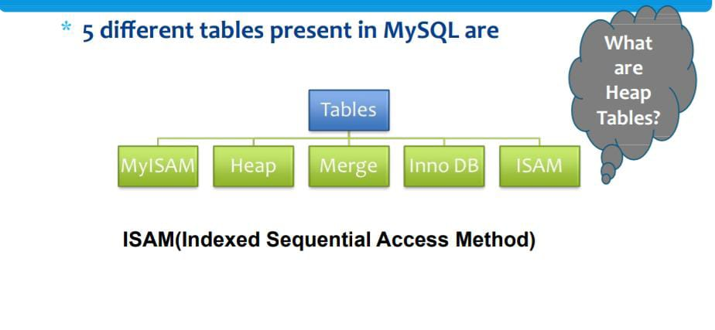

**Memory:** Stores data in RAM for fast access.

**Archive:** Efficient for storing large amounts of seldom-accessed data.

**6. Database Tables and Structure**

**Tables:** Organize data in rows (records) and columns (fields).

**Column Data Types:**

**Numeric:** INT, FLOAT, DECIMAL.

**Date/Time:** DATE, DATETIME, TIMESTAMP.

**String:** CHAR, VARCHAR, BLOB.

**7. Installing MySQL**

**On Linux:** Can be installed with RPM packages, e.g., MySQL-server-VERSION.glibc23.i386.rpm.

**Commands:** After installation, use mysql -u root -p to connect to the server.

**8. SQL Language Components**

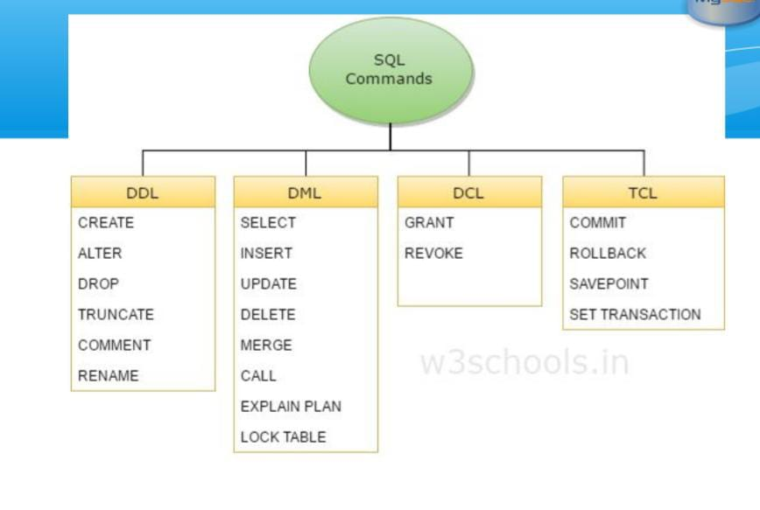

**DDL (Data Definition Language):** Commands like CREATE, DROP for defining structures.

**DML (Data Manipulation Language):** Commands like INSERT, UPDATE, SELECT for data manipulation.

**DCL (Data Control Language):** Commands like GRANT, REVOKE for permission control.

**9. Basic SQL Commands**

**SHOW:** Displays databases or tables.

**USE:** Selects a database.

**CREATE:** Defines new databases or tables.

**DROP:** Deletes tables/databases.

**INSERT:** Adds data rows to tables.

**SELECT:** Retrieves data, with options for conditions and sorting.

**UPDATE:** Modifies existing data records.

**10. Common SQL Clauses**

**WHERE:** Filters data based on conditions.

**ORDER BY:** Sorts data in ascending or descending order.

**11. Google Cloud SQL**

**Cloud Service:** Managed MySQL databases hosted by Google.

**Security:** Includes encryption and firewall protection.

**Applications:** Useful for WordPress sites, e-commerce platforms, CRM tools.